Web Tech Lab Question 5

22th September 2024

Question:

Make an image map showing the usage of shape, cords, href attributes in map. Link each hot-spot to their respective details. All the web pages should be designed with proper background color, images, font styles and headings.

OUTPUT:

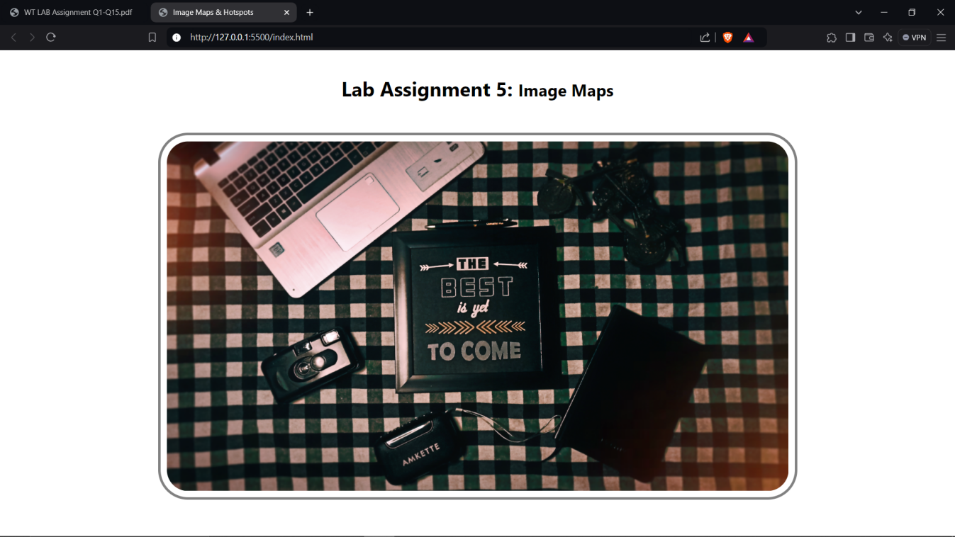

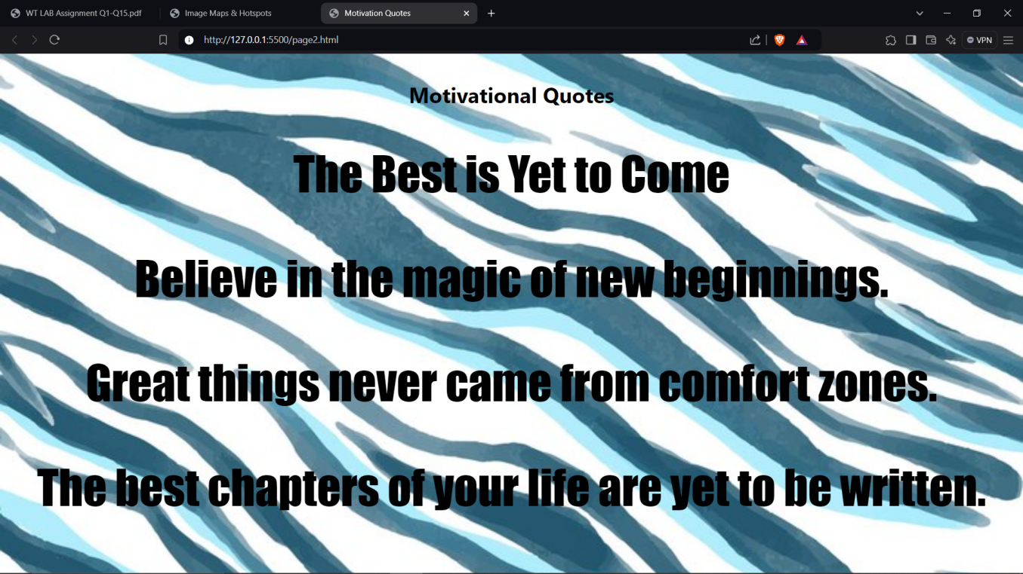

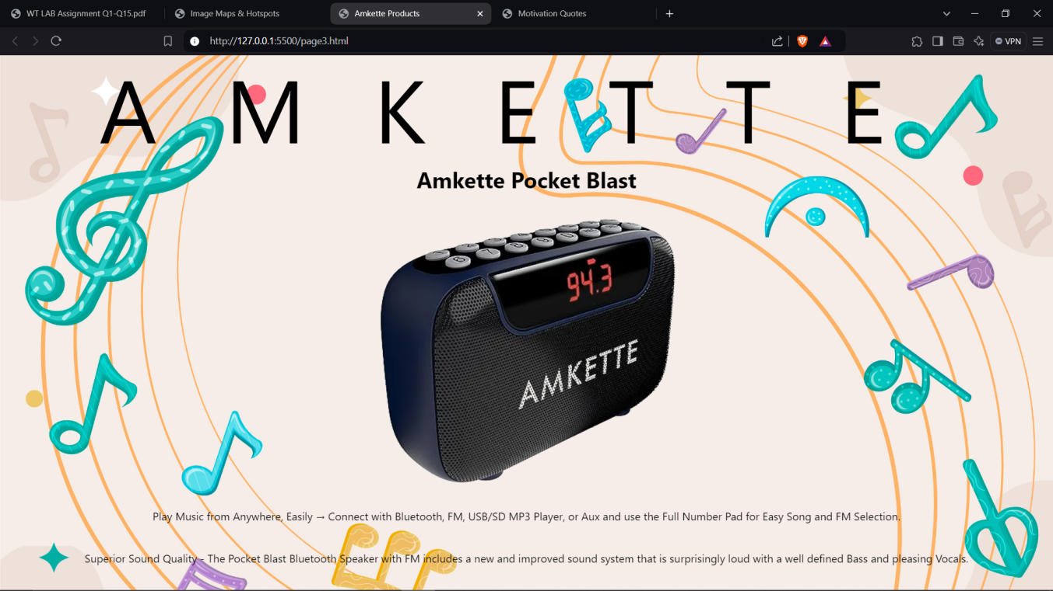

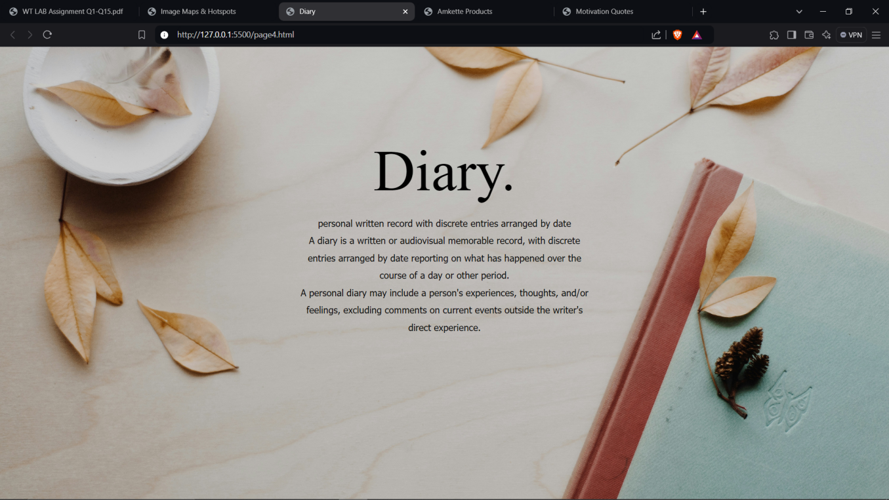

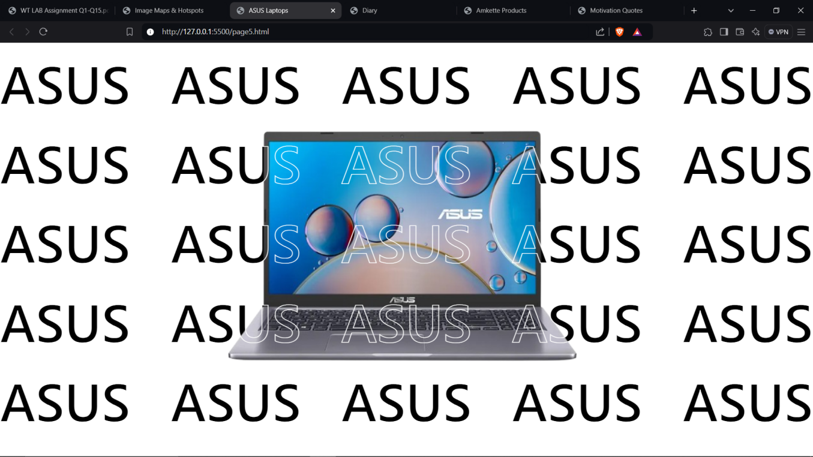

SOURCE CODE:

HTML

index.html

<!DOCTYPE html>

<html lang="en">

<head>

    <meta charset="UTF-8">

    <meta name="viewport" content="width=device-width, initial-scale=1.0">

    <title>Image Maps & Hotspots</title>

    <link rel="stylesheet" href="style.css">

</head>

<body id="indexPage">

    <h1 class="text">Lab Assignment 5: <small>Image Maps</small></h1>

    <map name="flatLay">

        <area shape="rect"

        coords="375,158,645,416"

        href="./page2.html"

        target="_blank">

        <area shape="poly"

        coords="383,494,434,432,478,527,363,652,333,514"

        href="./page3.html"

        target="_blank">

        <area shape="poly"

        coords="740,262,915,336,806,552,654,478"

        href="./page4.html"

        target="_blank">

        <area shape="poly"

        coords="0,9,236,295,544,56,505,0"

        href="./page5.html"

        target="_blank">

    </map>

    <img usemap="#flatLay" src="./Flat Lay.png" alt="Flat Lay" usemap="flatLay" id="mainImg">

</body>

</html>

page2.html

<!DOCTYPE html>

<html lang="en">

<head>

    <meta charset="UTF-8">

    <meta name="viewport" content="width=device-width, initial-scale=1.0">

    <title>Motivation Quotes</title>

    <link rel="stylesheet" href="style.css">

</head>

<body id="page2">

    <h1 class="text">Motivational Quotes</h1>

    <p class="text quotes"> The Best is Yet to Come</p>

    <p class="text quotes"> Believe in the magic of new beginnings.</p>

    <p class="text quotes"> Great things never came from comfort zones.</p>

    <p class="text quotes"> The best chapters of your life are yet to be written.</p>

</body>

</html>

page3.html

<!DOCTYPE html>

<html lang="en">

<head>

    <meta charset="UTF-8">

    <meta name="viewport" content="width=device-width, initial-scale=1.0">

    <title>Amkette Products</title>

    <link rel="stylesheet" href="style.css">

</head>

<body id="page3">

    <pre class="text amketteFont">AMKETTE</pre>

    <h1 class="text">Amkette Pocket Blast</h1>

    <img id="amketteImg" src="./Amkette.png" alt="Amkette">

    <p class="text">Play Music from Anywhere, Easily → Connect with Bluetooth, FM, USB/SD MP3 Player, or Aux and use the Full Number Pad for Easy Song and FM Selection.</p>

    <p class="text">Superior Sound Quality - The Pocket Blast Bluetooth Speaker with FM includes a new and improved sound system that is surprisingly loud with a well defined Bass and pleasing Vocals.</p>

</body>

</html>

page4.html

<!DOCTYPE html>

<html lang="en">

<head>

    <meta charset="UTF-8">

    <meta name="viewport" content="width=device-width, initial-scale=1.0">

    <title>Diary</title>

    <link rel="stylesheet" href="style2.css">

</head>

<body id="page4">

    <div>

        <p class="text diaryMain"> Diary.</p>

        <p class="text">personal written record with discrete entries arranged by date</p>

        <p class="text">A diary is a written or audiovisual memorable record, with discrete entries arranged by date reporting on what has happened over the course of a day or other period.</p>

        <p class="text">A personal diary may include a person's experiences, thoughts, and/or feelings, excluding comments on current events outside the writer's direct experience.</p>

    </div>

</body>

</html>

page5.html

<!DOCTYPE html>

<html lang="en">

<head>

    <meta charset="UTF-8">

    <meta name="viewport" content="width=device-width, initial-scale=1.0">

    <title>ASUS Laptops</title>

    <link rel="stylesheet" href="style2.css">

</head>

<body>

    <p class="text asusR">ASUS ASUS ASUS ASUS ASUS ASUS ASUS ASUS ASUS ASUS ASUS ASUS ASUS ASUS ASUS ASUS ASUS ASUS ASUS ASUS ASUS ASUS ASUS ASUS ASUS ASUS</p>

    <p class="text asusR2">ASUS ASUS ASUS ASUS ASUS ASUS ASUS ASUS ASUS ASUS ASUS ASUS ASUS ASUS ASUS ASUS ASUS ASUS ASUS ASUS ASUS ASUS ASUS ASUS ASUS ASUS</p>

    <img id="asusLPT" src="./asus.png" alt="ASUS LAPTOP">

</body>

</html>

CSS

style.css style2.css

|  |  |
| --- | --- |
| *{      margin: 0%;      padding: 0%;  }  .text{      margin-top: 40px;      text-align: center;      font-family:'Segoe UI', Tahoma, Geneva, Verdana, sans-serif  }  #page2{      background-image: url("./page2\ Bg.jpg");      background-size: cover;  }  #page3{      background-image: url("./music\ Bg.jpg");      background-size: cover;  }  #mainImg{      height: auto;      width: 1000px;      display: block;      margin: 50px auto;      padding: 10px;      border: 4px solid grey;      border-radius: 3rem;  }  .quotes{      font-size: 70px;      line-height: 15vh;      font-family: Impact, Haettenschweiler, 'Arial Narrow Bold', sans-serif !important;  }  .amketteFont{      font-size: 130px;      letter-spacing: 100px;      line-height: 90px;      margin: 30px 0px;  }  #amketteImg{      display: block;      margin: -50px auto;      padding: 10px;      mix-blend-mode:darken  } | *{      margin: 0%;      padding: 0%;  }  body{      overflow: hidden;  }  .text{      line-height: 30px;      text-align: center;      font-family:Tahoma, Geneva, Verdana, sans-serif;  }  #page4{      background-image: url("./diary\ Bg.jpg");      background-size: cover;  }  div{      margin: 200px auto;      width: 500px;  }  .diaryMain{      font-size: 100px;      font-family:'Gill Sans';      margin: 60px 0px;  }  .asusR{      font-family:'Segoe UI', Tahoma, Geneva, Verdana, sans-serif;      font-weight: 500;      font-size: 100px;      line-height: 150px;      text-align: justify;  }  .asusR2{      font-family:'Segoe UI', Tahoma, Geneva, Verdana, sans-serif;      font-weight: 500;      position: absolute;      top: 0;      z-index: 2;      font-size: 100px;      line-height: 150px;      text-align: justify;      -webkit-text-stroke: 1px white;      color: transparent;  }  #asusLPT{      width: 700px;      position: fixed;      z-index: 1;      top: 15vh;      left: 27vw;  } |